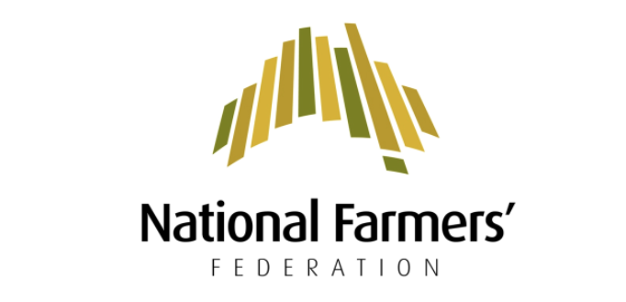
17 SEPTEMBER 2019
Former NFF President heads up Future Drought Fund Consultative Committee
The National Farmers’ Federation has welcomed today’s announcement of the Future Drought Fund Consultative Committee, to be led by former NFF President, Brent Finlay.
"The Committee includes esteemed Australians with a collective broad-cross section of skills and expertise and a passion and affinity for agriculture and it’s future," NFF President Fiona Simson said.
The NFF advocated strongly for the development of a consultative committee to direct the application of the $100 million Future Drought Fund.
"We welcomed the Government’s foresight in establishing the Fund to enable agriculture and regional Australia to better prepare for droughts into the future," Ms Simson said.
"It was of significant importance to the NFF that a Committee be established to ensure the funding was directed to the most effective projects - projects that would build farmers' and rural communities’ drought resilience for many decades to come."
The Future Drought Fund provides $100 million every year from 1 July 2020, for new investment in drought resilience and preparedness including in projects related to:
• research and innovation
• new technology
• better environmental and natural resource management
• infrastructure
• community initiatives
Ms Simson recognised today’s announcement as a major milestone in the Future Drought Fund process.
"The NFF looks forward to being consulted, through the Committee, on the development of the Drought Resilience Funding Plan, which will guide the Fund’s funding program for the next four years."
Mr Finlay is joined on the committee by Dr Wendy Craik AM; Dr Kate Andrews; Dr Elizabeth Peterson and Ms Caroline Welsh.
Ms Simson said the NFF was also working closely with the Government on the delivery of a long-overdue National Drought Policy.

